Date: 2014-07-07

PROBLEM SPECIFICATION

Filtering an image using Box Filter, Gaussian Filter and Laplacian Filter

INPUT

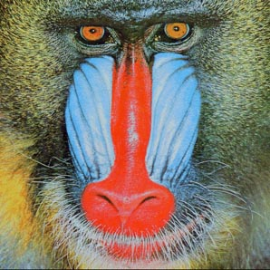

PROCESSING STEP

1. Load an image(I)
2. If image I is an RGB image convert into gray scale image  
   that is I=rgb2gray(I);
3. Get the copy of the Image I
4. For each intensity value in image I (starting from 3 to row-2 and like 3 to col-2) do :

Initialize an empty Matrix M

For each value in filter Matrix do :  
 Multiply each value in image I mentioned above with filter Matrixes each value and store it to M

End for

Find the mean of the M and store it to the representing value of I in copied image

End For

1. Do this step 1-4 for each filters Box, Gaussian and Laplacian
2. Finally plot the Filtered images and its histogram.

OUTPUT

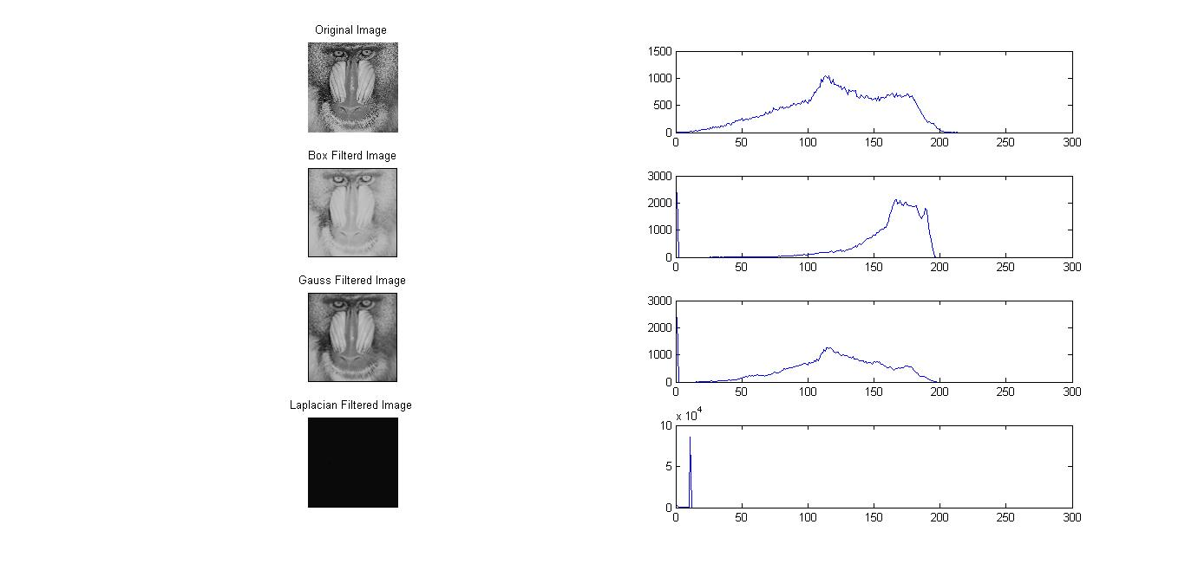

Program Listing

function [G] = GaussFilter(I,H)

if length(size(I)) == 3

I=rgb2gray(I);

end

[row,col] = size(I);

G=zeros(row,col);

for x=3:row-2

for y=3:col-2

M1=[];

for i=-2:2

for j=-2:2

a=I(x+i,y+j)\*H(i+3,j+3);

M1=[M1 a];

end

end

a=mean(M1);

G(x,y)=a;

end

end

G=uint8(G);

function [B] = BoxFilter(I,H)

if length(size(I)) == 3

I=rgb2gray(I);

end

[row,col] = size(I);

B=zeros(row,col);

for x=3:row-2

for y=3:col-2

M2=[];

for i=-2:2

for j=-2:2

a=I(x+i,y+j)\*H(i+3,j+3);

M2=[M2 a];

end

end

a=mean(M2);

B(x,y)=a;

end

end

B=uint8(B);

function [L]=Laplacian(I,H)

if length(size(I)) == 3

I=rgb2gray(I);

end

[row,col] = size(I);

L=zeros(row,col);

for x=3:row-2

for y=3:col-2

M3=[];

for i=-2:2

for j=-2:2

a=I(x+i,y+j)\*H(i+3,j+3);

M3=[M3 a];

end

end

a=mean(M3);

L(x,y)=a;

end

end

L=uint8(L);

function [h,I] = histogram(I)

K=256;

%Change Color image into Gray Scale

if length(size(I)) == 3

I=rgb2gray(I);

end

%Count the rows and Columns in image

[r,c]=size(I);

%Duplicate the image

h=zeros(1,K);

for i=1:r

for j=1:c

a=I(i,j);

h(a+1) = h(a+1)+1;

end

end

% Read the image

I=imread('./../images/baboon.jpg');

% Various filter

Gauss=[0 1 2 1 0;1 3 5 3 1;2 5 9 5 2;1 3 5 3 1;0 1 2 1 0];

Box=ones(5,5);

Lap=[0 0 -1 0 0; 0 -1 -2 -1 0; -1 -2 16 -2 -1 ; 0 -1 -2 -1 0; 0 0 -1 0 0];

% Genrate Filtered Image

[G] = GaussFilter(I,Gauss);

[B] = BoxFilter(I,Box);

[L] = Laplacian(I,Lap);

% Generate Hisograms

[h,I] = histogram(I);

[hG,G] = histogram(G);

[hB,B] = histogram(B);

[hL,L] = histogram(L);

% Show the images

subplot(4,2,1);imshow(I);

subplot(4,2,3);imshow(G);

subplot(4,2,5);imshow(B);

subplot(4,2,7);imshow(L);

% Plot Histograms

subplot(4,2,2);plot(h);

subplot(4,2,4);plot(hG);

subplot(4,2,6);plot(hB);

subplot(4,2,8);plot(hL);